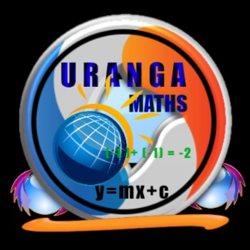

**Name…………………………………………………………… ADM Number:……………..**

**School:…...……….............................. Candidate’s Signature……………...…………..**

**121**

**Mathematics Alt.A**

**FORM THREE.**

**JULY 3RD 2024.**

**2 ½ Hours.**

**URANGA MATHEMATICS ASSOCIATION-2024.**

**Kenya Certificate of Secondary Education**

**MATHEMATICS 121**

**FORM THREE**

**TIME: 2 ½ HOURS**

**INSTRUCTIONS TO CANDIDATES:**

* Write your name, school, admission number and sign in the spaces provided above.
* This paper contains **TWO** sections: Section **I** and Section **II**.
* Answer **ALL** the questions in Section **I** and **FIVE** questions from section **II**.
* All answers and working **MUST** be written on the question paper in the spaces provided below each question.
* Marks may be given for correct working even if the answer is wrong.
* Non-programmable silent electronic calculators and KNEC Mathematical tables may be used, except where stated otherwise.

**FOR EXAMINERS USE ONLY**

**SECTION I**

|  |  |  |  |  |  |  |  |  |  |  |  |  |  |  |  |  |
| --- | --- | --- | --- | --- | --- | --- | --- | --- | --- | --- | --- | --- | --- | --- | --- | --- |
| **1** | **2** | **3** | **4** | **5** | **6** | **7** | **8** | **9** | **10** | **11** | **12** | **13** | **14** | **15** | **16** | **Total** |
|  |  |  |  |  |  |  |  |  |  |  |  |  |  |  |  |  |

**SECTION II**

**Grand Total**

|  |  |  |  |  |  |  |  |  |
| --- | --- | --- | --- | --- | --- | --- | --- | --- |
| **17** | **18** | **19** | **20** | **21** | **22** | **23** | **24** | **Total** |
|  |  |  |  |  |  |  |  |  |

*This paper consists of 15 printed pages. Candidates should check to ascertain that all pages are printed as indicated and that no questions are missing.*

**SECTION I (50 MARKS)**

**Answer ALL the questions in this section**

1. Evaluate  without using a calculator. (3 marks)
2. Simplify $\frac{√5}{2\sqrt{2}- √5}$ leaving your answer in the form $a+b√c$ (3 marks)
3. Solve for $x$ in the equation; log(7 $x$ + 2) – log($x$– 1) = - 2 (3 marks)
4. Make $x$ the subject of the formula (3 marks)

$P = \frac{qx}{\sqrt[3]{m+tx^{3}}}$

1. Simplify fully the expression (3 marks)
$$\frac{6x^{2}-9xy-6y^{2}}{8x^{2}-2y^{2}}$$

2. Given that, find the exact value of. (3 marks)
3. A Kenyan bank buys and sells foreign currencies as shown below.



A businessman travelling from France arrived in Kenya with 19 500 Euros. He converted all the money into Kenya shillings at the bank. While in Kenya, he bought a car for Ksh 1 200 000 and spent another Ksh 87 000 then he converted the remaining amount into Japanese Yen. Calculate the amount to the nearest Yen that he received. (3 marks)

1. Solve the inequality  and determine the sum of all the integral values. (3 marks)
2. In the figure below, ABCD is a parallelogram in which AB = 12 cm, BC = 8 cm and angle

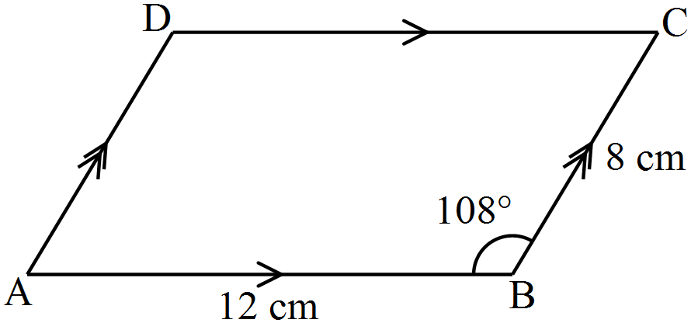

Calculate the area of the parallelogram correct to 3 significant figures. (3 marks)

1. Given that **OA** = 2**i** – 3**j** and **OB** = 4**j** – **i** find the magnitude of **AB** correct to **2** decimal places.

(3 marks)

1. Construct a circle centre P and radius 3cm. Construct a tangent from point Q 7cm from the centre P to touch this circle at R. Measure the length of QR. (3 marks)
2. A supermarket has 18 apples, 30 oranges and 54 mangoes. The fruits are to be arranged in rows such that each row contains the same number of fruits of each kind. Calculate the total number of fruits in each row for which the number of rows used is maximum. (3 marks)
3. Using a ruler and a pair of compass only, construct a trapezium PQRS in which PQ is parallel to SR, PQ = 10cm, PS = 6cm and angle QPS = 75o. Drop a perpendicular from R to meet PQ at X. Measure RX. (4 marks)
4. A man withdrew some money from a bank. He spent  of the money on his daughter’s school fees and  of the remainder on his son’s school fees. If he remained with Ksh 10 500, calculate the amount of money he spent on son’s school fees. (3 marks)
5. The length of a rectangular room is 3 m more than its width and the area of the room is 40 m2. The room is to be carpeted leaving a uniform margin of 20 cm all around. Calculate the area of the margin. (4 marks)
6. Determine the percentage error when 2 $\frac{2}{13}$ is written as decimal and truncated to 4 significant figures.

(3 marks)

**SECTION II (50 MARKS)**

**Answer Any 5 Questions from this section**

1. In the figure below, ABCD is a trapezium in which AB = 17 cm, AD = 16 cm and angle. AB is parallel to DC and AB = BD.

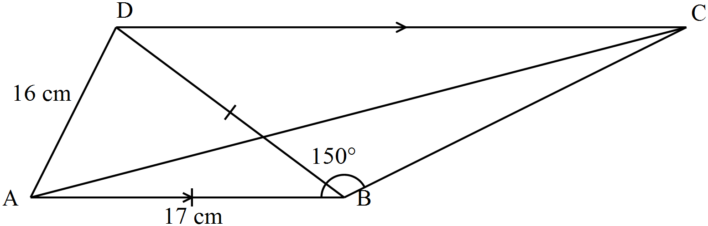

1. Calculate the area of triangle ABD. (2 marks)
2. Calculate correct to 2 decimal places:
3. The length of BC. (2 marks)
4. The length of AC. (3 marks)
5. The size of angle ACD. (3 marks)
6. A straight line L1 passes through the points  and.
7. Find the equation of the line L1 in the form  where a, b and c are integers. (3 marks)
8. The line L1 meets the x – axis at R.
9. Find the coordinates of R. (1 mark)
10. Another line L2 is perpendicular to L1 at R. Find the equation of L2 in the form  where m and c are constants. (3 marks)
11. A third line L3 is parallel to L2 and passes through the point. Find the point where L3 and L1 intersect. (3 marks)
12. (a) Complete the table below correct to 2 decimal places. (2 marks)



1. Using a scale of 1 cm for  on the x – axis and 2 cm for 1 unit on the y – axis, and on the same axes, draw the graphs of  and  for. (5 marks)

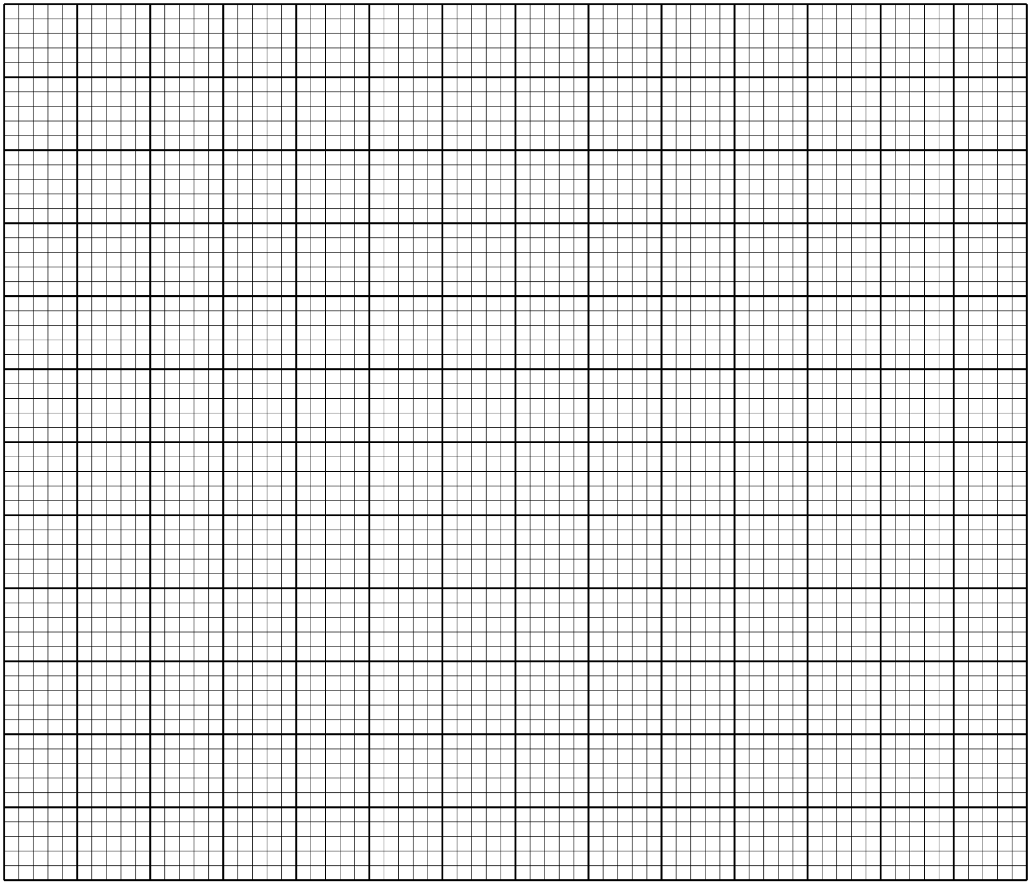

1. Using the graph in (b) above, solve the equation. (2 marks)
2. Find the range of values of *x* for which. (1 mark)
3. The vertices of a triangle ABC are.
4. On the grid below, draw the triangles ABC. (1 mark)

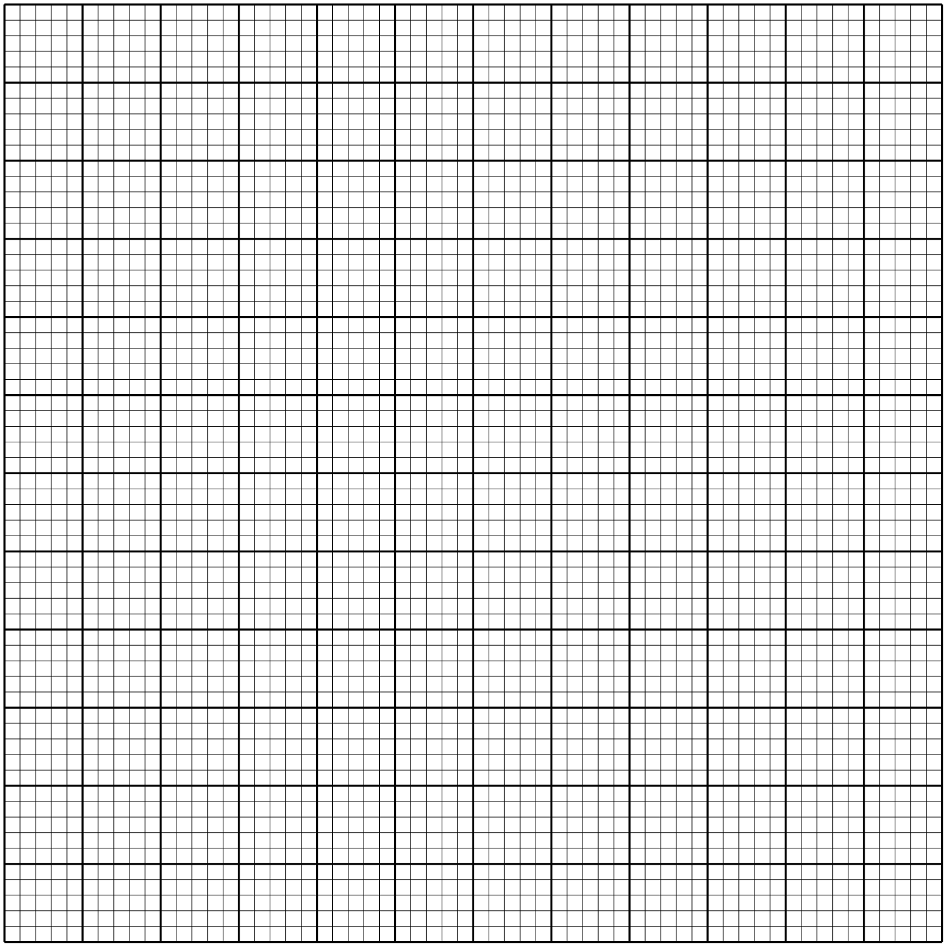

1. , the image of triangle ABC under a negative quarter turn about the origin. (2 marks)
2. , the image of triangle  under reflection in the line. (2 marks)
3. Triangle  with vertices  is the image of triangle  under a transformation **T**.
4. Draw the triangle. (1 mark)
5. Describe fully the transformation **T**. (2 marks)
6. State **any** pair of triangles which are:
7. Directly congruent. (1 mark)
8. Oppositely congruent. (1 mark)
9. The distance between Kakamega and Kisii is 196 km. A matatu left Kakamega at 8.00 a.m. for Kisii at an average speed of 54km/h. After 40 minutes, a van left Kisii for Kakamega using the same route at an average speed of 66km/h. the two vehicles met at Awasi.
10. Calculate:

(i). the time when the two vehicles met. (3 marks)

(ii). the distance between Awasi and Kakamega (3 marks)

1. On the same day, a car left Kakamega for Kisii using the same route at an average speed of 90km/h and caught up with the matatu at the same time as the van. Find:

(i). the time when the car left Kakamega. (2 marks)

(ii). the distance of the car from Kisii at 10.54 a.m. (2 marks)

1. a). The first term of an arithmetic progression is 2. The sum of the first 8 terms of the AP series is 240.

(i). Find the common difference of the AP. (2 marks)

(ii). Given that the sum of the first $n$ terms of the AP is 1560. Find $n$. (3 marks)

b) The 3rd, 5th and 8th terms of another AP form the first three terms of a GP. If the common difference of the AP is 3. Find:

(i). the first term of the GP. (3 marks)

(ii). the sum of the first 9 terms of the GP to 4 significant figures. (2 marks)

1. (a) Find the value of q if the matrix **B** = $\left(\begin{matrix}q & 2 \\ -3 & q+5\end{matrix}\right)$ is singular. (3 marks)
2. A trader placed on display 8 shirts and 5 pairs of trousers valued at Ksh. 49 600. If she reduced the number of shirts by 2 and increased the number of pairs of trousers on display by 2, the value of the items increases to Ksh 52 800.

i). Taking $x and y$ to be the prices of a shirt and a pair of trousers respectively, form a matrix equation to represent this information. (1 mark)

ii). Determine the price of each item using matrix method. (4 marks)

1. The trader sold each shirt at 20% profit and each pair of trousers at 25% profit. Calculate the percentage profit she made by selling a shirt and a pair of trousers. (2 marks)
2. Mr. Mwangi bought a cooker on hire purchase by paying 15 monthly installments of Ksh 950 each. The cash price of the cooker was sh 3750 more than the carrying charge. Calculate the:
3. Carrying charge (2 marks)
4. Cash price (1 mark)
5. Rate of compound interest charged per month (4 marks)
6. Rate of simple interest charged per annum. (3 marks)